CS590BD Big Data Analytics and Apps

**LAB - 5**

**Report on Motion Based Game app using**

**Data Processing and Motion Recognition app**

**By**

**Ponnam Balakrishna**

**16177831(BP8G6)**

**On-line motion based game app using Data Processing and Motion Recognitions apps:**

For developing the game with sensors I have downloaded android open source game from the github. The game I downloaded is **Tetris** which is known to everyone who played videogame in the childhood.

The following is the git hub link from which I have downloaded the code:

<https://github.com/semenoh/Tetris>

**Overview of the Game:**

The game is Tetris where we get different objects which we can rotate all those objects and can move towards the left and towards right. On moving those it will be coming down if it made a row then the row will be collapsed and level goes on increasing once it touch the upper the game will be over.

**How the game implemented using sensor devices:**

The game is modified for developing the game to use with the sensor devices. For operating the game with sensor devices we have developed the app for collecting the data. The data I have collected is by using the Samsung app which collects the accelerometer, Humidity, and Temperature data. The data gesture I have collected for this application is **Left to Right**, **Right to Left** and **Rotation**.

I have collected all the **Left to Right**, **Right to Left** and **Rotation** data by training and testing those text data files I have generated the **Sequential File.** Based on the Sequential file generated we play the game by giving the motions Right to Left, Left to Right and to rotate.

To those downloaded code I have added three classes for running with sensor one of the class for establishing the sensor connection. One of the classes is for identifying the patterns by comparing with the probability of the gesture.

In Android Manifest I have added some of the permissions and the Bluetooth connection and some of the services.

ConncetionService 🡪 This Class is added for establishing a connection with the sensor by using the UUID tags and collecting the data of particular service as present I have taken accelerometer, Humidity and Temperature.

SensorTagData 🡪 This class is added for collecting the data from the sensor tag which is connected and matching those data with the sequential file which is added by training the data.

TestGesture 🡪 This class is added giving the sequence file and for choosing the gesture from the data to which side need move it may be Right, Left or to rotate which is done by comparing with the probability.

AndroidManifest 🡪 Have added the services, Established Bluetooth connection and the permissions.

And some of the supporting Jar files and the Google play service API.

Those above mentioned are the some of the changes done to the source code available.

The below screen shows the function calling the motion method:

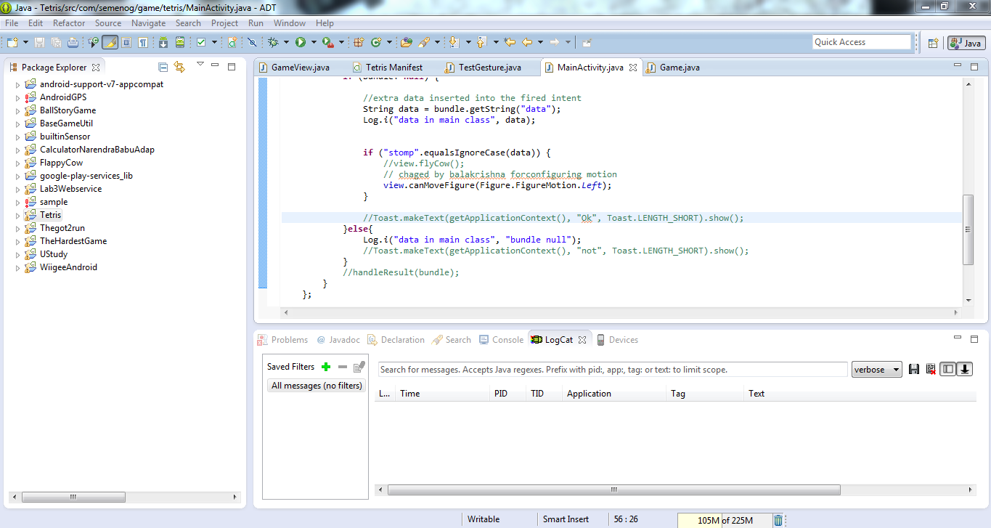

On calling the motion method it detects what motion it is and perform the particular operation of the motion weather to move Left, Right or to rotate.

The below screen shows the **onTouchEvent** method:

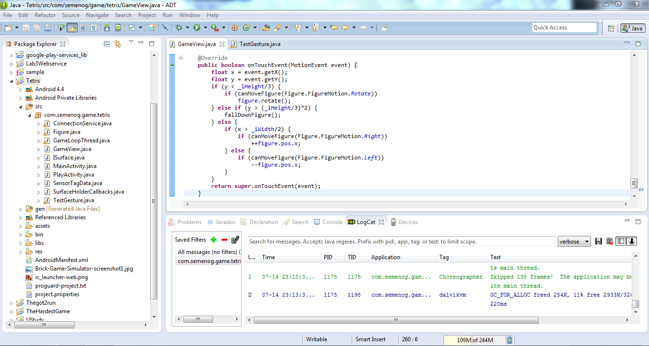

The **onTouchEvent** method checks the condition and position of the object and then based on the motion it moves the object towards the detected motion which may be Right, Left or Rotation.

The below screen shows the probability of the gesture:

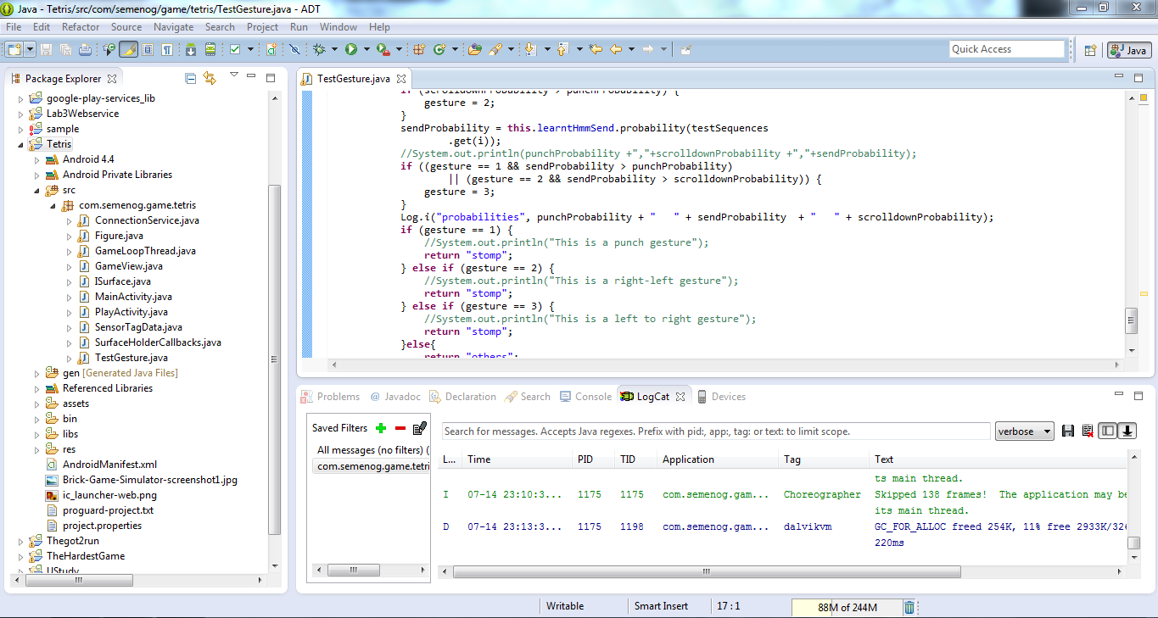

The above code in the screen checks the probability of the gesture and decides the motion to be generated and then calls the particular method for the motion.

The below screen shows the Android manifest file: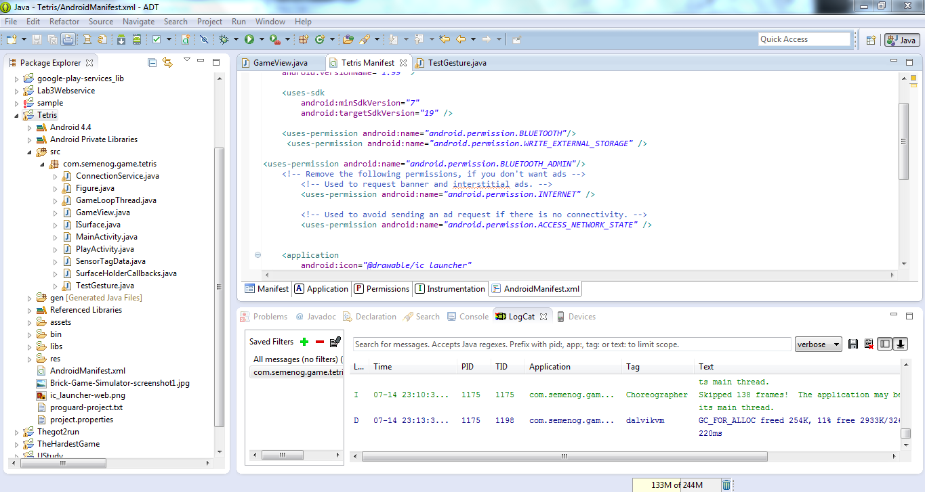

The above screen shows the android manifest file which has added some services and Bluetooth connections.

In the Textgesture class we add the sequential files which are generated. I need three files Left to Right, Right to Left and the rotation for this game. So I have collected those three sequential files and included.

The below screen shot shows the adding rotation generated sequential file to the test gesture class:

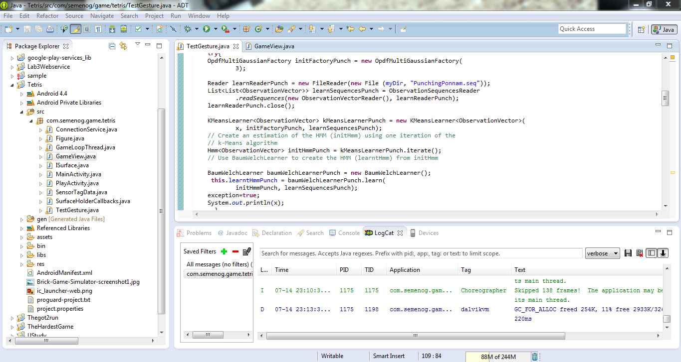

The below screenshot shows the adding Left to right generated sequential file to the class:

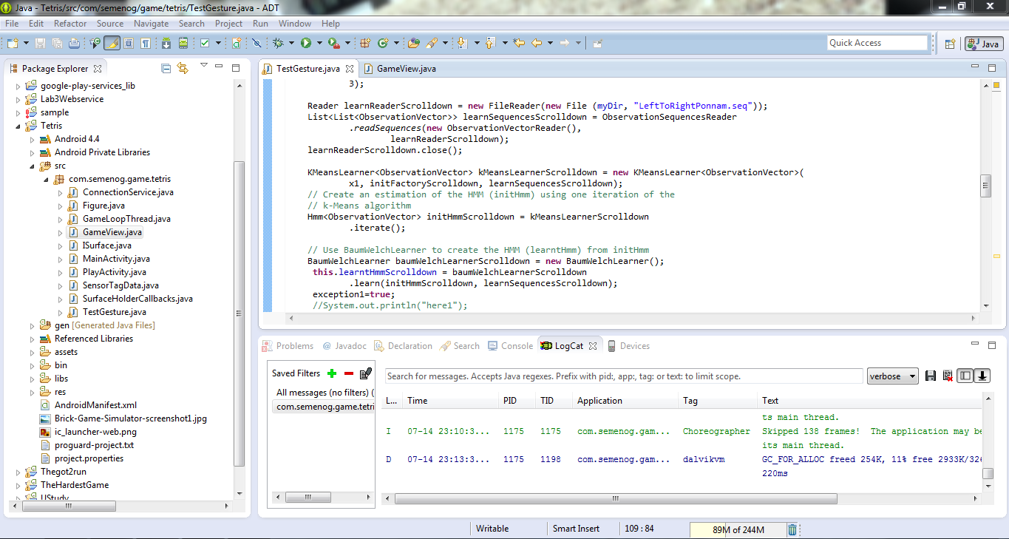

**Running Game:**

On running the game with sensor devices we get the Play button.

The below screen shot shows the beginning of the game with the play button:

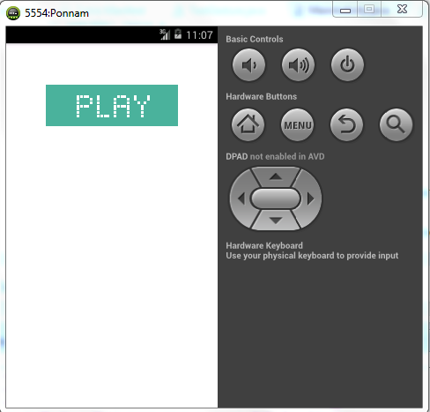

On pressing the play button the game will be running by generating the objects. Those objects can be moved towards Right and Left and can also rotate the object.

The object goes down untill it reaches top.We can move the object and make a row without any space so that the row will be deleted. If we got the row with some spaces then no row will be deleted and the objects get add on adding and touch the top where the game get over.

Here the code is modified to make the objects movable by using the sensor data where before the sensor data is trained and tested data with sequential files where the motion can be trained and perform the action.

The below screen shows the objects falling down and which can be moved left and right:

